**--->Asymptotic Analysis**

This analysis is basically done to find out the order of growth

of a program.

The best part is, it does not depend on any programming language

It is algorithm specific not test case specific

Here no need to implement the algorithm, we have to analyse it.

Let us take and example now to get an idea of Asymptotic analysis.

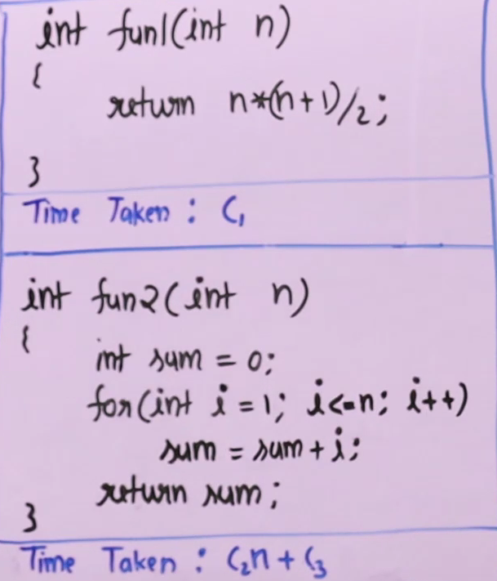

Here we are performing 3 operations

Assuming that the time taken for any value of n time taken is same and constant

So that’s why time taken is written as C

Some things executing n times and some things at constant n

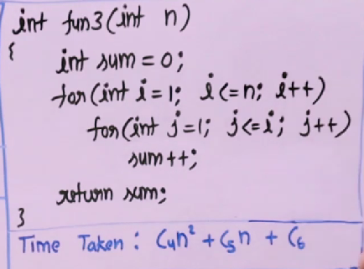

Similarly, since the loop is executing n^2 time so the time is in quadratic

So, the idea of growth is: Leading term of time taken

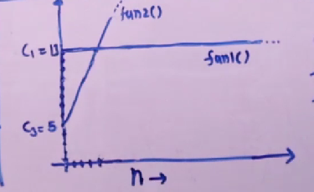

Example C1=13

C2=2 and C3=5

Fun1()=13

Fun2()=2n+5

Here after the intersecting value the fun2 grows linearly but fun1 is constant, that’s is order of growth.

In asymptotic analysis we figured out that something which has higher order of growth we will have a higher value after certain value of n.

:)